**Digital Twin Tag Meeting Minutes**

**Date:** March 1st, 2023

**Location:** [Microsoft Teams Link](https://teams.microsoft.com/l/meetup-join/19%3ameeting_MDhjNTg4ZDktZGFlYy00ODc0LTliYzQtMjc4MTA3ZTc3NmQ1%40thread.v2/0?context=%7b%22Tid%22%3a%22d41fdab1-7e15-4cfd-b5fa-7200e54deb6b%22%2c%22Oid%22%3a%222516780d-2412-48c9-8447-e24d7322175f%22%7d)

**Agenda**

* Show Ryan scanner ui so far
* Request sample of API tags
* Present to Ryan our plan for the next few weeks
* Inform Ryan on who’s doing what right now on the team

**Discussion Notes**

* Ryan presented a tag with a WIP code we can use while working on the project
* Should be given remote access to local machine tomorrow from Ryan
* Asked to confirm what our limits are in terms of how much data we are storing in the database
  + Ryan thinks we’re overestimating how much data we will actually need to store and re-explained what exactly will need to be stored and how much space it’ll take
* For the arena system want 20 hz and the code is written dynamically for the player side
* Not predictable when a shift will happen but there's usually always a shift going on
  + Is it manual based on position of the tags and the mean and find the threshold
  + If we can find mean movement of all sensors, if nothings moving production off, if things are moving production on
* Need these basic statistics defining zones and the floor and quick count of how many orders in each zone, applying zone to current wip number to see how many wips in each zone
  + Doesn’t have coordinates for the zones but can provide us with ___(didn’t hear what hes giving us) but it’ll help us present it on the front end
  + Alois asked do have an idea of what the boundaries are or can we make sample zones?
  + Ryan said yes you can make sample zones for now, have a map but there are a lot of zones and we may not need all of them so he will get back to us
* Gabriel most important to see where the live one is now
* Ryan was wondering if the aggregator is it something on the physical machine at the company or on a cloud?
  + Alex said thinking of using a cron job which runs 24 hours on physical machine where Ryan and them are at
  + Ryan thinks we need a middle man that will take from eliko and push to AWS
* Had to be on eliko wifi according to documentation, to access it remotely would have to port a bunch of stuff in, could have our own network and then have eliko access that
* Have been given permission to use Amazon PostgreSQL (have given us login data)

**Action Items**

* Share GitHub repository with Ryan
* Send Ryan a message tomorrow to remind him to send samples of the tags that we can use for testing API calls
* Ryan will provide us with a graphic of the different zones and will confirm which ones we actually need to include
* Ryan will provide sample tags for development, has given one us the one below
* 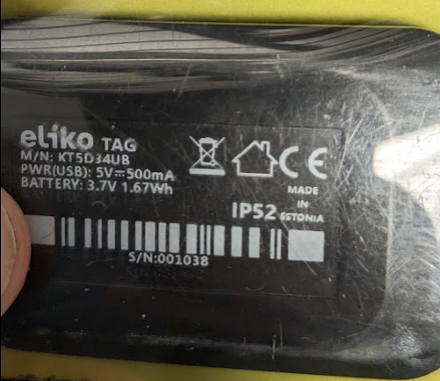
* Ryan will give access to stand-alone app by tomorrow (remote access) for scan